skumar@travelodesk.com
- Please share reference sites for the design of the website.
Skumar - https://docs.google.com/spreadsheets/d/1NNyBVH4mYZ1gRa9Sscm4SgnpsRyIXIUjM2GeWX1Ifhg/edit?usp=sharing
- skumar@travelodesk.comI requested for access, please give access
Skumar - given access

- Regarding Domain we are going to have only www.travelodesk.com hosted and both
www.travelodesk.in and www.travelodesk.co.in to be forwarded to above.
Skumar - Yes

- As discussed on call, tdp@zasya.online has been created - skumar@travelodesk.com please use this email to send any communication for this project, varaprasad, Lakshmi and Ramesh will receive email
- skumar@travelodesk.comPlease share cloudflare access details
Skumar - access details provided below -

- Kindly find cloudflare access below :
- https://dash.cloudflare.com/login

- Email :
- support@travelodesk.com
- password:
- Mickey123@

skumar@travelodesk.com:
1) Travel o desk - ops center Login credentials
2) API from booking.com, - need Login credentials to explore current fleet management and booking management system
3) Current aws details for db access
4) Google map API details
5) SMTP gateway to test email services.
6) SMS gateway
7) Whatsapp API
8) Paypal payment gateway details
9) Razorpay payment gateway details
10) Logo and Colour pattens to start the UI / UX Design.

1) Travel o desk - ops center Login credentials
link - https://ops.travelodesk.com/logout
id - skumar@travelodesk.in
password - tisha123@

2) API from booking.com, - need Login credentials to explore current
fleet management and booking management system

for API, we have sent an email but login credentials are below -

Link - https://portal.taxi.booking.com/
Email - support@travelodesk.com
password - Plasterofparis123@

https://ops.travelodesk.com
id - tisha@travelodesk.in
Password: November

3) Current aws details for db access

https://signin.aws.amazon.com/signin?redirect_uri=https%3A%2F%2Fus-east-1.console.aws.amazon.com%2Fec2%2Fhome%3Fregion%3Dus-east-1%26state%3DhashArgs%2523Home%253A%26isauthcode%3Dtrue&client_id=arn%3Aaws%3Aiam%3A%3A015428540659%3Auser%2Fec2&forceMobileApp=0&code_challenge=U67XvipY_7N87V_mdxaRk_VvRDwDAWVXkV7FyBGqses&code_challenge_method=SHA-256

Root User
Email - skumar@travelodesk.com
Password - Kursi123@

4) Google map API details

This will be shared soon

5) SMTP gateway to test email services - You need to find in using our email id -

support@travelodesk.com
Cadbury123@

client id: 67876969560-ba9ccjfe5s334jsvel557rm5ci0bsned.apps.googleusercontent.com

client Secrect id: 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

auth code: 4/0AfJohXlArwwk8qj3INnB1LJqiT8kjjVfc5nb0B3Ljufm6PCLobeX2q8CQMu3BJSy0USuHQ

ref token: 1//04TfuNo71dpFYCgYIARAAGAQSNwF-L9IraFS_Ff-sXubxg9C1A5iwbhcNu9cYVj433_QlAdEGUE16NQKuDoTHl1jLKPx62ScgyEE

access token: ya29.a0AfB_byDKpgdKW-U6RFoAXHa8ogk-6e5kyJvttoWj3IMyinsMSGwE5bfEnmAaar53j7zm8gcVPROxtuz8XyoGEV_Rb-RhAbOG5AG0xShlvVDoCRoEHH2xeZ-eKXEqyoF28NABISB4h8d6zY_NN7Gy5PerHnTUGDaLPt6MaCgYKAfoSARESFQHGX2MilO5t2kN7u4jXBMGyBwXCcg0171

6) SMS gateway -- We don't have , we will have to buy
7) Whatsapp API - We don't have , we will have to buy

8) Paypal payment gateway details -
Client Id - AR7ryMIGifhnUENlYrEDOb3Bx-Ef_UvH_ieIUyXTthQHO-1bbG9PVOGGPRy-0tdRgoaBOMuAkgXXUlvg
Secret - EJU8m2Shi5GCAGpfc_2kMQjIWH2_NlsaG_Dg2uOuSP8a-ldq_CpcB4OP2HKCmKLxlB9TK9iNd2e8z_qs
Email id - accounts@travelodesk.in

9) Razorpay payment gateway details --

Live Key Id - rzp_live_2haGa0v8YQVKmd
secret - EJU8m2Shi5GCAGpfc_2kMQjIWH2_NlsaG_Dg2uOuSP8a-ldq_CpcB4OP2HKCmKLxlB9TK9iNd2e8z_qs
Email - accounts@travelodesk.in
Password: Mouse123@

10) Logo and Colour patterns to start the UI / UX Design.

Logo, we need to create again, We are going to share a link of website where your team can show their graphic & web designing skills
https://hertz.com
==============

Feed from Sushil Kumar - Below -
Dashboard Look -
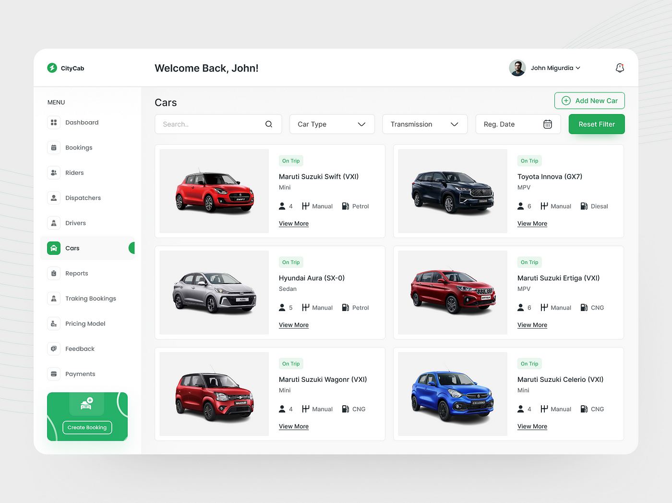
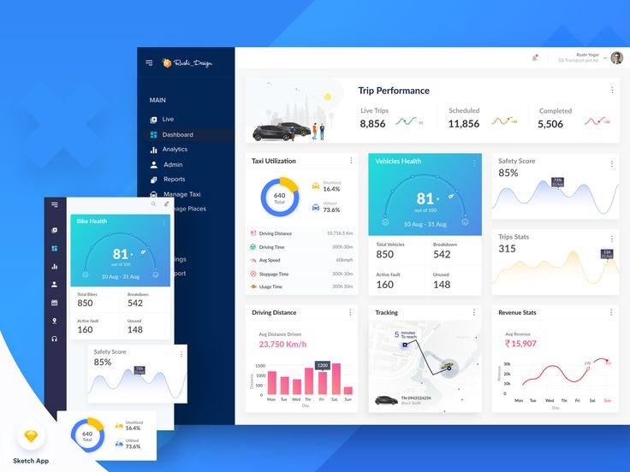
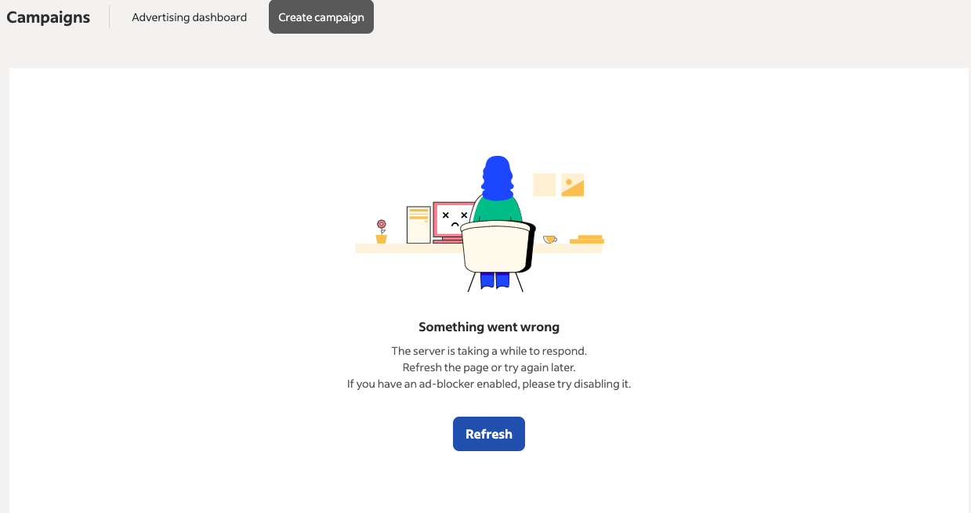
Cancellation Policy -
If booking is canceled 24 hours prior to your pick up time, there will not be any cancellation fee, You will get 100% refund other than bank charges / payment gateway charges. Else if booking gets canceled within 24 hours or during the journey, there will be 100% cancellation fee.
=====================================================================
Adding the vehicle & the driver -
https://partner.transfeero.com/index.php?red=
Login credentials -
support@travelodesk.com
Id -Transfeero123@
For Airport Transfers, Adding cities
https://portal.taxi.booking.com/
support@travelodesk.com
Plasterofparis123@
https://providers.mozio.com/login
support@travelodesk.com
Notebook123@
https://op.12go.asia/
skumar@travelodesk.com
ghjcnjq

=========================================================================

Home Page Website Reference Below & A few designs to get the idea from -
Banner - 1
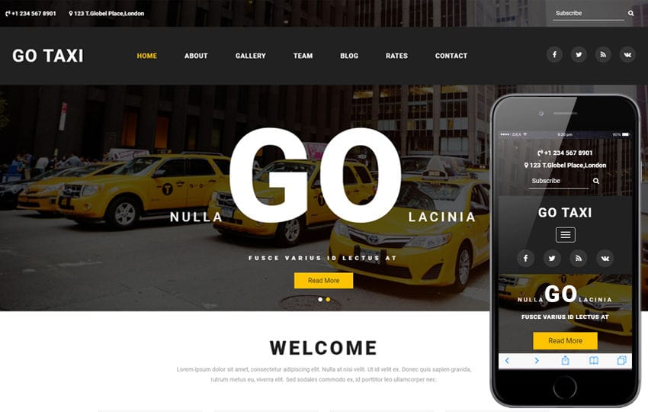
Banner -2
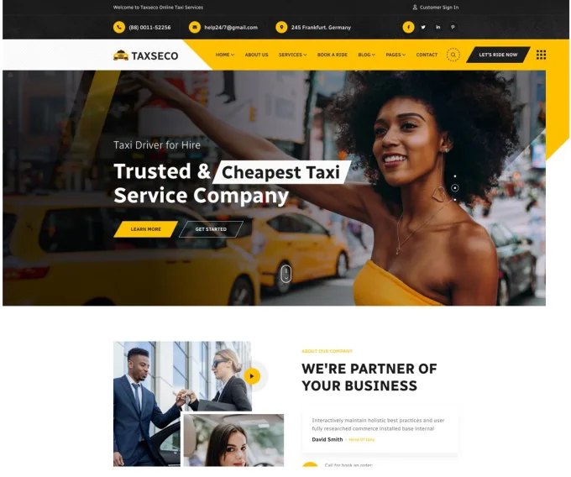

Banner - 3
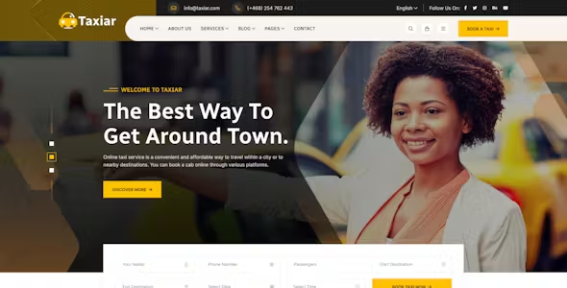
Banner - 4
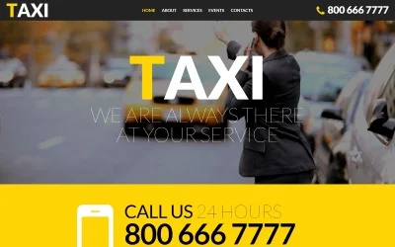

Banner - 5
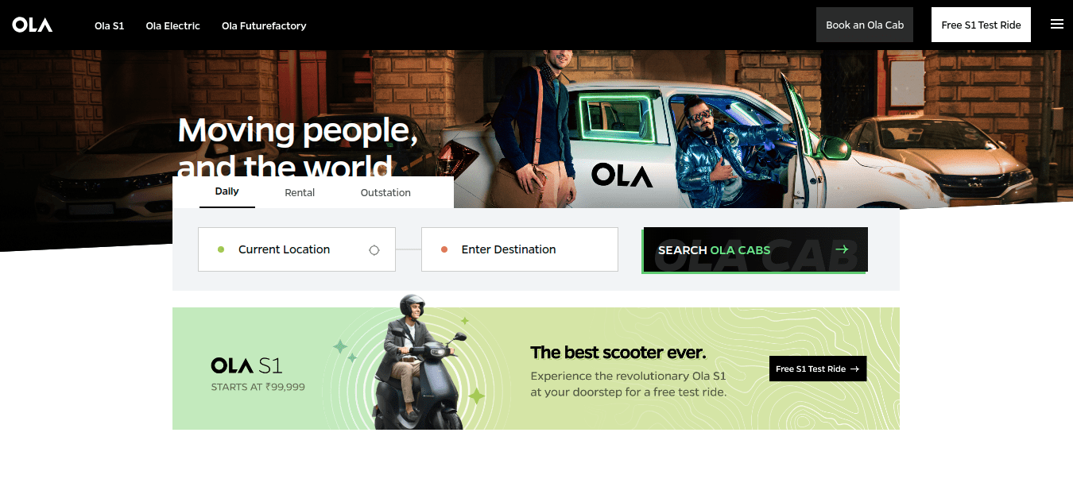
A few websites links below -
https://www.lyft.com/
https://www.didiglobal.com/
https://www.transfeero.com/en/
https://www.gett.com/uk/
https://www.taxi2airport.com/en/
https://www.olacabs.com/
https://indrive.com/en/home/
https://www.lonelyplanet.com/india
https://airportstaxitransfers.com/

Few more links to have an idea, what kind of design we are expecting from designer -
https://www.pinterest.com/pin/345229127685901485/
https://www.pinterest.com/pin/1050535050555040771/
https://www.pinterest.com/pin/698972804682392406/
https://www.pinterest.com/pin/web-templates--93238654777955188/
https://www.pinterest.com/pin/805862927086976185/
Contact Us / Enquiry Page Design Idea Below -
https://www.pinterest.com/pin/345229127685901610/
Top of the footer shall have dynamic rates for popular routes as below -
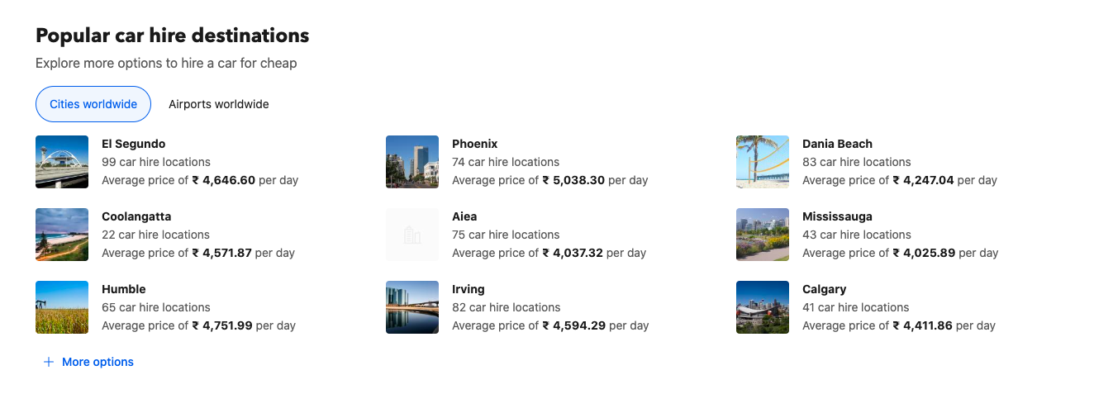
All The Trip Logic Below -
Airport Transfer
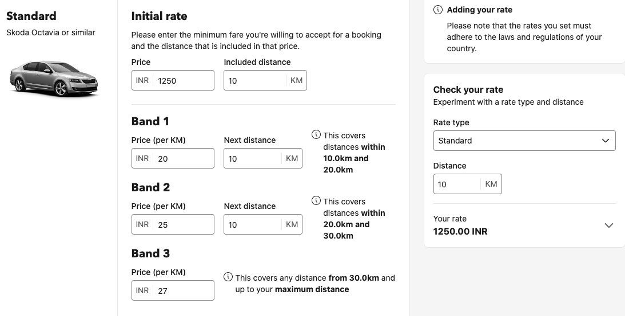
One Way - Transfer

We will add the routes and their price --
From City To City -- Vehicle Type -- Trip Type - One Way - Price All Inclusive
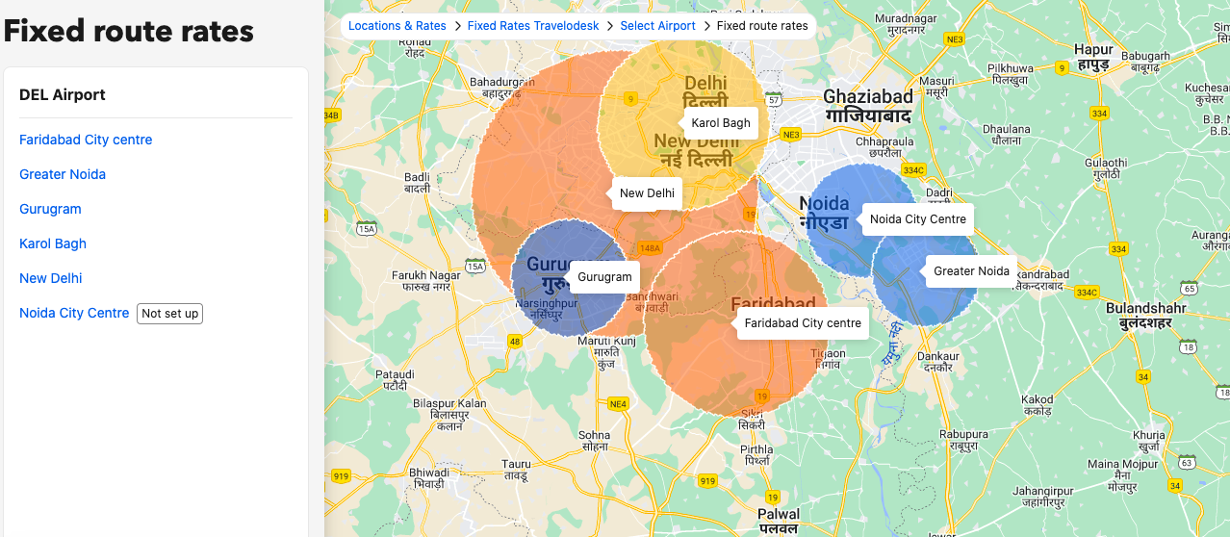

If any one way route is not available and passenger is searching for that rates, then Airport Transfer Logic will help the passenger to find the rates for that rates
Multi Cities - One Way Transfer
Same logic as One Way but passengers shall be able to select from one city to another city and add more cities and check the total amount for all the one way trips and book it.
Also passengers shall be able to modify a particular one way trip or remove one of them during the process.
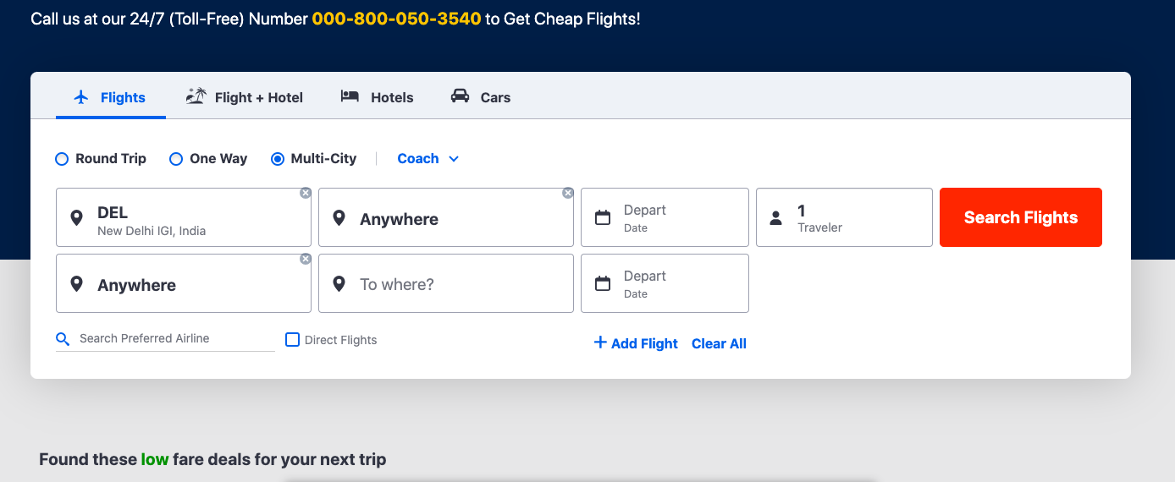

Local Trip - Business Visit
Passenger will be able to check the for Local trip based on our entry for that particular city-
4 Hours / 40 Kms
5 Hours / 50 Kms
8 Hours / 80 Kms
10 Hours/100 Kms
12 Hours / 120 Kms

Example -
8 Hours / 80 Kms Base Price - 1500, Extras ( Per Km Rate, Per Hour Rate )
Tolls & Parking Fee As Per Actual
Local Trip - Sightseeing

Name of City
Duration
Date of Travel
Pick up Time
Location
Submit Your Enquiry
========

Vehicle Page Sample -
https://www.travelodesk.com/vehicles-to-choose

https://www.hertz.com/rentacar/vehicleguide/index.jsp?targetPage=vehicleGuideHomeView.jsp&countryCode=IN&category=Car/Sedan
Driver Page Sample -
https://www.travelodesk.com/professional-drivers

Driver’s Form Link - https://docs.google.com/document/d/1ftDcVScjzqQYyEeIO0mxWYknT0IbVh9t6QhJBfw9B8Q/edit?usp=sharing

